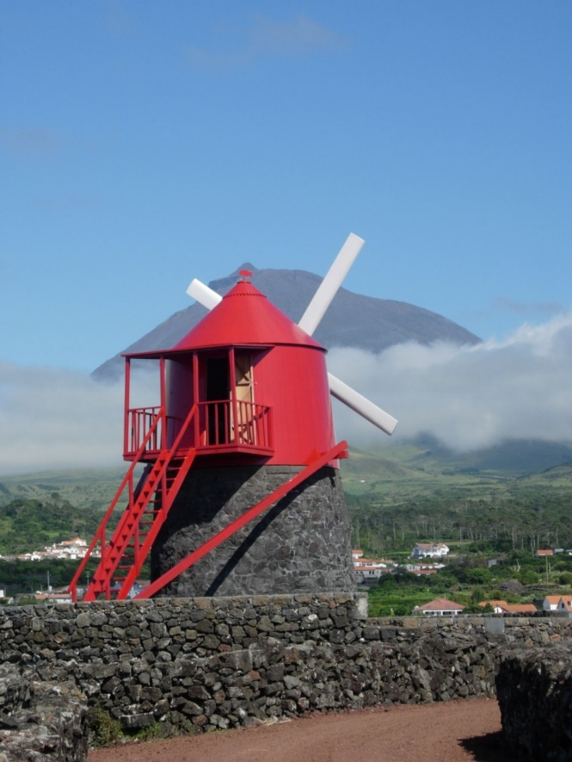

Trail of extinct and active volcanoes, earthquakes across Europe
First Transnational Meeting, 23rd – 26th November 2015
Final Report
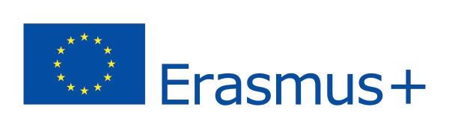

According to the application form of the ERASMUS + project mentioned above, two teachers from each partner schools and coordinating schools met for the first time in the Portuguese partner’s school with the following action programme:
- Getting to know each other;
- Adjusting and redefining the project according to each partner school’s possibilities;
- Appointing the responsible partner for the writing of each meeting report;
- Outlines for the creation of the logo of the project;
- Setting the dates of the first teachers and students exchange in Naples, Italy;
- Defining what has to be done until the first meeting and what teachers and students are expected to do in Italy.
The organizing Portuguese school welcomed all the partner schools in a formal cerimony with the presence of a representative of the Portuguese school board. On the occasion the partner schools offered the organizing school some souvenirs. Finally, the organizing school offered all the participating teachers a souvenir that had been prepared by the teachers and students that participate in the project.
Since this was the first time all the teachers met, this activity was used as an ice-breaker between the participants.
Afterwards, the coordinator of the the welcoming school invited the project coordinator to take the lead and to start the working programme.
Each school made a short presentation and then the coordinator set some recommendations so that the collaborative work between the six schools can develop smoothly. Here are the recommentations:
- There should be a good communication between the different partner schools. For that reason the coordinator created two facebook groups, one only for theachers and a second one for teachers and students. Simultaneously, the coordinator created a web page where all the activities of the project will be published and accessible to the general public.
- It is also important that the teachers respond as fast as possible to the e-mails sent by the coordinator. Even if there is no concrete answer, the partners should always comment and say when they expect to give a definite answer to each subject.
- The coordinator asked the partners to send all the information, photos, reports of any activity so that the coordinator can upload them into the web page.
- The partner schools should promote the project web site in their school, as well as at a local and national level (whenever possible).
After that, the coordinator reminded the partners of the main objectives of the project: to improve the geological and biological knowledge among teachers and students; getting acquainted with different methods of monitoring volcanoes and earthquakes; motivate teachers and students to improve their knowledge on the subject of the project.
Referring to the second topic of the meeting, the partners analysed the development of the project so far and decided final dates to conclude some of the activities that are delayed. The month of January should be considered as a deadline for the activities thar were supposed to be concluded until the end of December 2015. It is importat to conclude the initial test of knowledge on volcanoes and earthquakes immediately, and launch the activity of the volcano models among the students in each school. It is also importat to launch the competition among teachers for the best lesson plan on volcanology.
According to the third topic of the meeting, it was agreed that each welcoming partner should take the responsibility of writing the report of each meeting.
In relation to point four, the partners agreed on a competition to create the logo of the project. The Portuguese partner took the responsibility of organising the rules for that competition.
Regarding topic number five, the partners agreed on the dates for the meeting in Italy. The meeting shall take place from the 6th to the 10th April, 2016, travel days excluded.
Finally the partners decided that the visiting students and the welcoming students should held a 15-minute presentation per partner school. The students shall present their volcanoes whether they are active or extinct. After these presentations the students should meet in mixed groups (one student from each participating country) and should be able to analyse the differences and similarities between their regions. In the end the groups should share their ideas. This presentations should deal with geology, geography, biology and chemistry as main topics.
Besides this formal meeting, the international teachers from the partner schools met some classes of the organising school and presented their schools and their regions to the Portuguese students. The participants had also the opportunity to visit the town hall and to meet with the mayor of Madalena.
The teachers had some time to visit important geological sites on the island of Pico and had also the chance to participate in some local cultural events.

